CHAROTAR UNIVERSITY OF SCIENCE AND TECHNOLOGY
FACULTY OF TECHNOLOGY AND ENGINEERING (FTE)
DEVANG PATEL INSTITUTE OF ADVANCE TECHNOLOGY AND RESEARCH
QUESTION BANK 1: UNIT 1
Which one of the following is not an Evolutionary Process Model?
WINWIN Spiral Model
Incremental Model
Concurrent Development Model
Spiral Model
All are Evolutionary Software Models
What is the major advantage of using Incremental Model?
Customer can respond to each increment
Easier to test and debug
It is used when there is a need to get a product to the market early
Both b & c

The spiral model was originally proposed by
IBM
Barry Boehm
Pressman
Royce

How is Incremental Model different from Spiral Model?
Progress can be measured for Incremental Model.
Changing requirements can be accommodated in Incremental Model.
Users can see the system early in Incremental Model.

Give scenario base explanation of Spiral model and explain its architecture with advantages and disadvantages.
ANS:
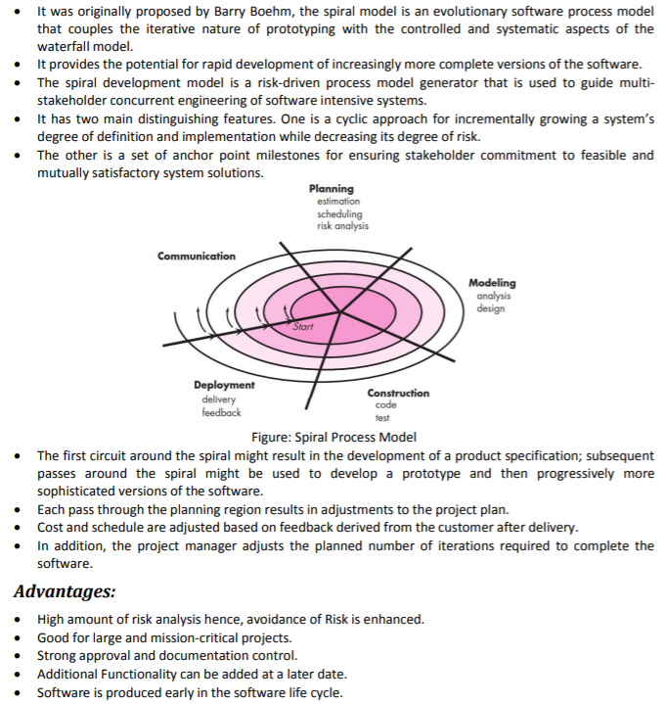
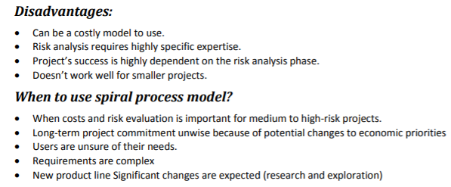

Why software engineering is a layered Technology?
ANS:
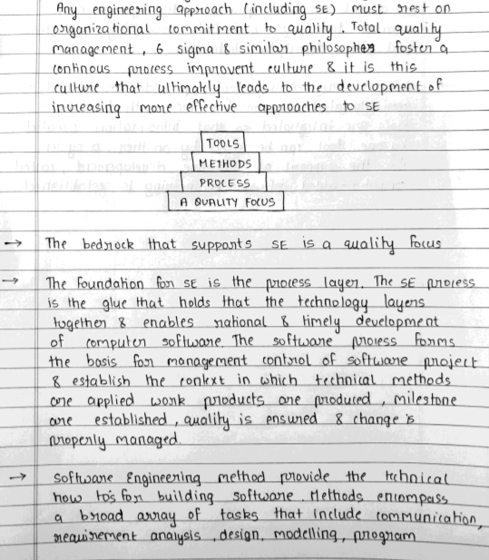
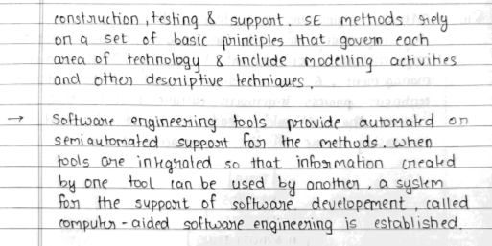

Define different types of software Myths.
ANS:
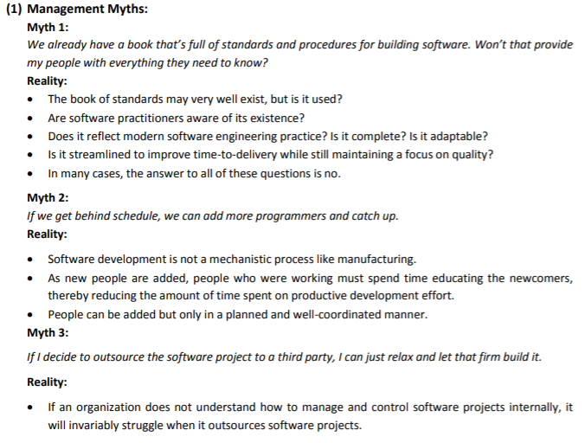
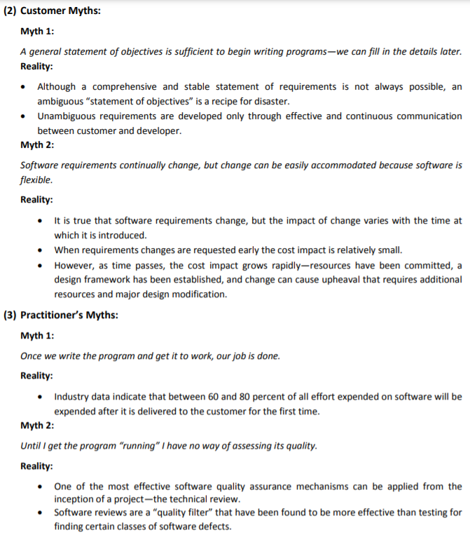

In what situations will you use waterfall model? Justify your answer. Name the risk-based software development process model? What are its advantages and disadvantages?
ANS:
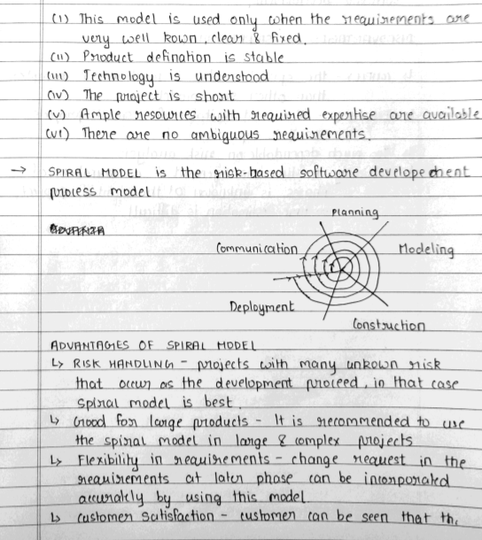
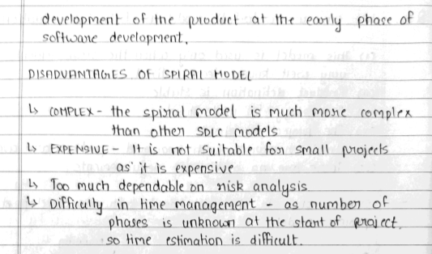

What do you mean by software process models? Why we need it? Distinguish between software product and software process. Name four process models that are used to develop large software systems.
ANS:
A software process model is an abstraction of the software development process. The models specify the stages and order of a process. So, think of this as a representation of the order of activities of the process and the sequence in which they are performed.
A model will define the following: (NEED)
- The tasks to be performed
- The input and output of each task
- The pre and post conditions for each task
- The flow and sequence of each task
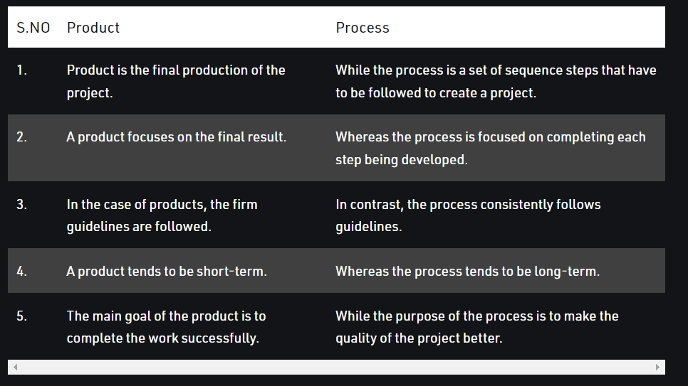
- Waterfall model
- V model
- Incremental model
- RAD model
- Agile model
- Iterative model
- Prototype model
- Spiral model

Why does the waterfall model sometimes fail?
ANS:
Waterfall uses the theory that what you want at the beginning is what you get at the end so there is little, if any room, for significant changes in direction. Being an inflexible model, which does not provide for feedback, it is difficult to highlight new requirements and thus change course. The creation of new software needs to be responsive to changes in technology, any problems encountered along the way, ideas originating from the developers and, last but not least, constantly changing customer needs. If you use Waterfall you end up with pretty much what you had planned at the beginning and that may no longer be relevant.
The Stages
Since Waterfall employs stages, it maintains the belief that each phase must be 100% complete before moving on to the next. This rigidity has an obvious problem; if your project needs unexpected changes or revisions, you must go back to where the requirement has to be altered and start that phase all over again. This will almost certainly incur added costs in terms of time and money. If the problem is not addressed, then it is most likely that the product will end up being sub-standard and unacceptable to the end user.
The End User
Waterfall concentrates very little on the end user of a product. As a methodology, it focuses more on guiding the internal process of development and helping the teams within it. The constantly changing needs of end users are not considered because they are rarely involved. They neither have input nor are updated on the progress of the project so it is quite likely that the end product will be unacceptable to them. This runs the risk of causing the worst-case scenario; namely, that if released and then rejected by the consumer, the entire project will have to go back to the very beginning and be completely redone.
Quality Testing
Quality testing does not appear in Waterfall until you are into the second half of the project. Therefore, if you are at an advanced stage when you discover quality problems with the product its flow can be blocked. Imagine the bottom of a real waterfall and how the direct flow of water can be disrupted by a few over-hanging tree trunks. It is also quite likely that, by leaving testing until the latter stages of a project, the teams involved may cut this phase short since they are under pressure to complete before a time deadline.
No Overlapping
Processes within this model do not overlap and, as a result, efficiency is undoubtedly reduced. Therefore, critics argue that it is not satisfactory for complex, high risk and object-orientated projects.

What are the major phases of the entire life of the software? specify the percentage of efforts required on each phase. Which phase requires the maximum efforts? Which phase is/are more creative?
ANS:
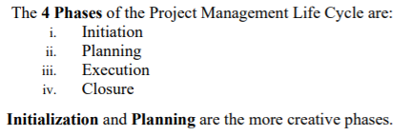
If formal methods can demonstrate software correctness, why is it they are not widely used?
ANS:

Compare the relative advantage of using the iterative waterfall model and the spiral model of software development. Explain with the help of examples, the type of problems for which you would adopt the waterfall model of software development, and the type of problems for which you would adapt the spiral model.
ANS:

What do you mean by software lifecycle model(s)? is it compulsory to follow it while developing a project? Explain in brief.
ANS:
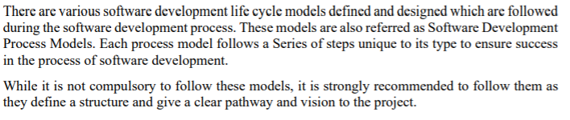
What formal techniques are available for assessing the software process?
ANS:

Define software and software engineering. What are the characteristics of software?
ANS:
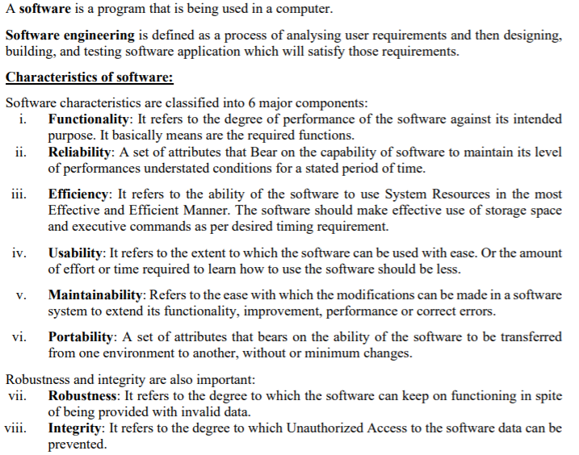

Show how the failure curve of software differs from that of hardware. Software doesn’t wear out but it deteriorates due to change. Justify. How do software myths affect a software project?
ANS:
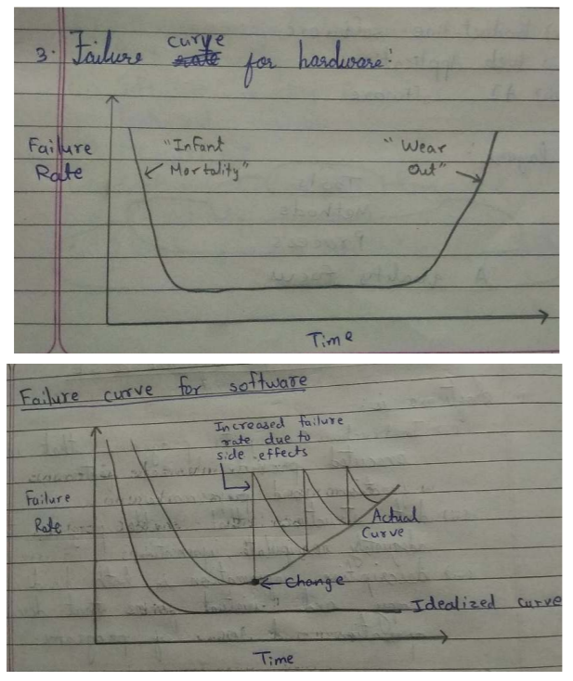
If you are a lead developer of a software company and you are asked to submit a project/product within a stipulated time-frame with no cost barriers, which model will you select?
Waterfall
Incremental
Spiral
RAD

Explain which process model is most suitable for the following definition and justify it:
A compiler for new language
Event management system
Chess
ANS:
  - Compiler for a language: Spiral Model
Justification: First, we release a barebones version with basic functionalities and then tighten its integration with various OS’s. Security and Stability (Risk Analysis) is important as it needs to work for many applications and not simply as an application.
  - Event Management System: Incremental Model
Justification: Requirements shall increase as the company grows and events become more diverse. Thus Incremental (version-based) approach shall be more appropriate.
  - Chess: Waterfall Model
Justification: Already a fixed problem. Approaches are fixed. Not much scope for improvement. Mostly a one-off project and quite small. Thus, Waterfall approach shall be appropriate.
Differentiate throw-away v/s evolutionary model.
ANS:
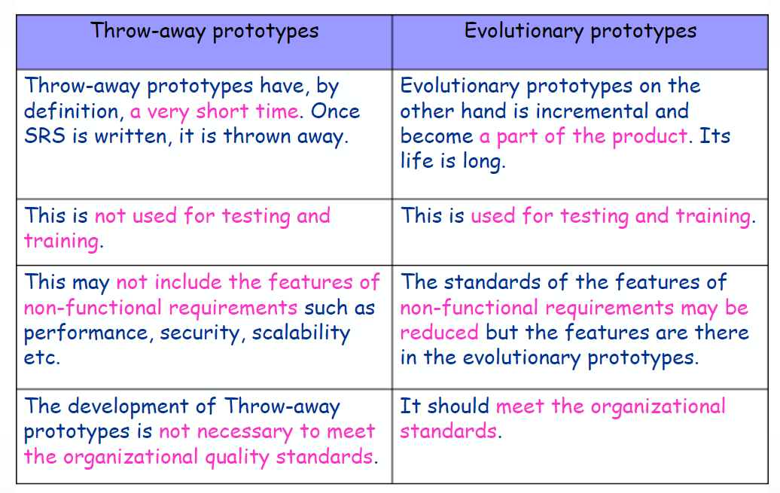

Explain with a neat sketch “A software process framework”.
ANS:
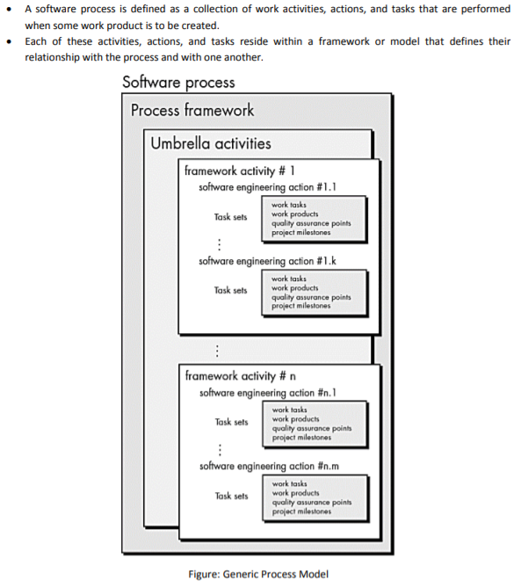
How does a framework activity change as the nature of the project changes?
ANS:

What is a process pattern?
ANS:
Process patterns can be defined as the set of activities, actions, work tasks or work products and similar related behaviour followed in a software development life cycle.
Type :
It is of three types :
- Stage pattern
Problems associated with a framework activity for process are described by stage pattern. Establishing Communication might be an example of a staged pattern. This pattern would incorporate task pattern Requirements Gathering and others.
- Task-pattern
Problems associated with a software engineering action or work task and relevant to successful software engineering practice (e.g., Requirements Gathering is a task pattern) are defined by task-pattern.
- Phase pattern
Even when the overall flow of activities is iterative in nature, it defines sequence of framework activities that occurs within process. Spiral Model or Prototyping might be an example of a phase pattern.
